eLib and Examiner

programming guide
2026

Majid SharifiTehrani
PhD Systematic Botany
https://www.msht.ir

1- eLib 3
usrs 4
User_Project 4
Paths 4
Papers 4
Projects 4
SubProjects 5
Links 5
Notes 5
NoteNet 5
Settings 5
tblConnections 6
tblNotesCount 6
tblSecurityCodes 6
frmAssign2 7
namespace eLib.Assign : int mode 7
class Client 9
class Db 9
class Assign 9
class eLibFile 10
class Security 10
class Instance 10
class Report 10
Registers 10
2- Exam 12
Courses 12
CourseTopics 12
Entries 12
ExamComposition 12
ExamParticipants 12
Exams 12
ExamSheets 12
ExamTests 13
Participants 13
Settings 13
TestOptions 13
Tests 13
class Testbank 14
class Testbank: methods 16
Registers 18
3- Augustus 19
ArrowData 19
Clusters 19
NoteNet 19
Sequences 19
species 19
Transcripts 19
- 19
4- Encode 20
Prefix (tsnnn) 20
Encoding chars (tsnnnthh) 20
Suffix (xnnn) 21
Decoding 21
TABLE Ascii codes, coefficients 22

1- eLib

Remote server: eLib - Local servers: eLibA, eLibB

usrs
SQLServer | DS | Class
0 ID int  1 UsrName nvarchar(50)  2 UsrPass nvarchar(50)  3 UsrActive bit  4 UsrSN nvarchar(255)  5 acc int  6 FolderPapers nvarchar(255)  7 FolderBooks nvarchar(255)  8 FolderManuals nvarchar(255)  9 FolderLectures nvarchar(255)  10 FolderTemp nvarchar(255)  11 FolderSaveACopy nvarchar(255)  12 UsrNote nvarchar(255)  13 UsrInterface int | tblUsrs  0 ID  1 UsrName  2 UsrPass  3 UsrActive  4 UsrSN  5 acc  6 FolderPapers  7 FolderBooks  8 FolderManuals  9 FolderLectures  10 FolderTemp  11 FolderSaveACopy  12 UsrNote  13 UsrInterface | User.AdminPass = ****  User.Id  User.Type  User.Name  User.Pass  User.Accs  User.FolderPapers  User.FolderBooks  User.FolderManuals  User.FolderLectures  User.FolderTemp  User.FolderSaveACopy  User.NotesDay0  User.NotesDay1  User.NotesDay2  User.NotesDay3  User.NotesDay4  User.NotesDay5  User.NotesDay6  Methods:  ValidateFolders()

User_Project
0 User_Id int  1 Project_Id int  2 ReadOnly bit | tblUserProject  0 User_Id  1 UsrName  2 UsrNote  3 Project_Id  4 ReadOnly

Paths
0 FilePath nvarchar(255)  1 StorageSN nvarchar(20) | tblRefPaths  0 FilePath  1 StorageSN

Papers
0 ID int  1 PaperName nvarchar(255)  2 IsPaper bit  3 IsBook bit  4 IsManual bit  5 IsLecture bit | tblRefs  0 ID  1 PaperName  2 Is1Paper  3 IsBook  4 IsManual  5 IsLecture | Ref.Id  Ref.TypeCode  Ref.TypeText  Ref.Title  Ref.Attributes  Ref.ImportStatus

Projects
0 ID int  1 ProjectName nvarchar(255)  2 Notes nvarchar(255)  3 Active bit  4 User_ID int | tblProject  0 ID  1 ProjectName  2 Notes  3 Active  4 user_ID  tblProj_tmp  0 ID  1 ProjectName | Project.Id  Project.Name  Project.Note  Project.IsActive

SubProjects
0 ID int  1 SubProjectName nvarchar(255)  2 Notes nvarchar(255)  3 Project_ID int | tblSubProject  0 ID  1 SubProjectName  2 Notes  3 Project_ID  tblProd_tmp  1 ID  2 SubProjectName  3 Notes  tblProd_tmp2  0 SubProject.Id  1 SubProject.Name | SubProject.Id  SubProject.Name  SubProject.Note

Links
0 ID int  1 Paper_ID int  2 SubProject_ID int  3 Imp1 bit  4 Imp2 bit  5 Imp3 bit  6 ImR bit | tblLinks  0 Papers.ID  1 PaperName  2 IsPaper  3 IsBook  4 IsManual  5 IsLecture  6 SubProject_ID  7 Links.ID AS LinkID  8 Imp1  9 Imp2  10 Imp3  11 ImR  tblAssignments  0 ID  1 Paper_ID  2 SubProject_ID,  3 SubProjectName  4 Imp1  5 Imp2  6 Imp3  7 ImR | Link.Id

Notes
0 ID int  1 NoteDatum char(18)  2 Note nvarchar(4000)  3 Parent_ID int  4 ParentType tinyint  5 Rtl bit  6 Done bit  7 User_ID int  8 Shared bit  9 ReadOnly bit | tblSNotes  tblLNotes  tblRNotes  tblUNotes  tblDNotes  0 ID  1 NoteDatum  2 Note  3 Parent_ID  4 ParentType  5 Rtl  6 Done  7 User_ID  8 Shared | Note.Type  Note.Index  Note.Saved  Note.Id  Note.NoteText  Note.DateTime  Note.Rtl  Note.Done  Note.UserID  Note.ParentID  Note.ParentType  Note.days  Methods:  GetSNotesFromDB()  GetThisNote()  PostpondNote()  SaveNote()

NoteNet
0 ID int  1 NoteA_ID int  2 NoteB_ID int | tblNoteNet  0 ID  1 NoteA_ID  2 NoteB_ID

Settings
0 ID int  1 sttHeader nvarchar(50)  2 sttKey nvarchar(50)  3 sttValue nvarchar(255)  4 sttNote nvarchar(255) | tblSettings  0 ID  1 sttHeader  2 sttKey  3 sttValue  4 sttNote

tblConnections
tblConnections
0 name
1 address
2 initcat
3 usr
4 pwd
5 sn

tblNotesCount
tblNotesCount
0 ProjectName
1 SubProjectName
2 NoteDatum
3 Note
4 Projects.ID
5 SubProjects.ID
6 Notes.ID
7 Done
8 Rtl

tblSecurityCodes
tblSecurityCodes
0 Ascii_Code
1 Alt1
2 Alt2
3 Alt3
4 Alt4
5 Alt5
6 Coeff

frmAssign2
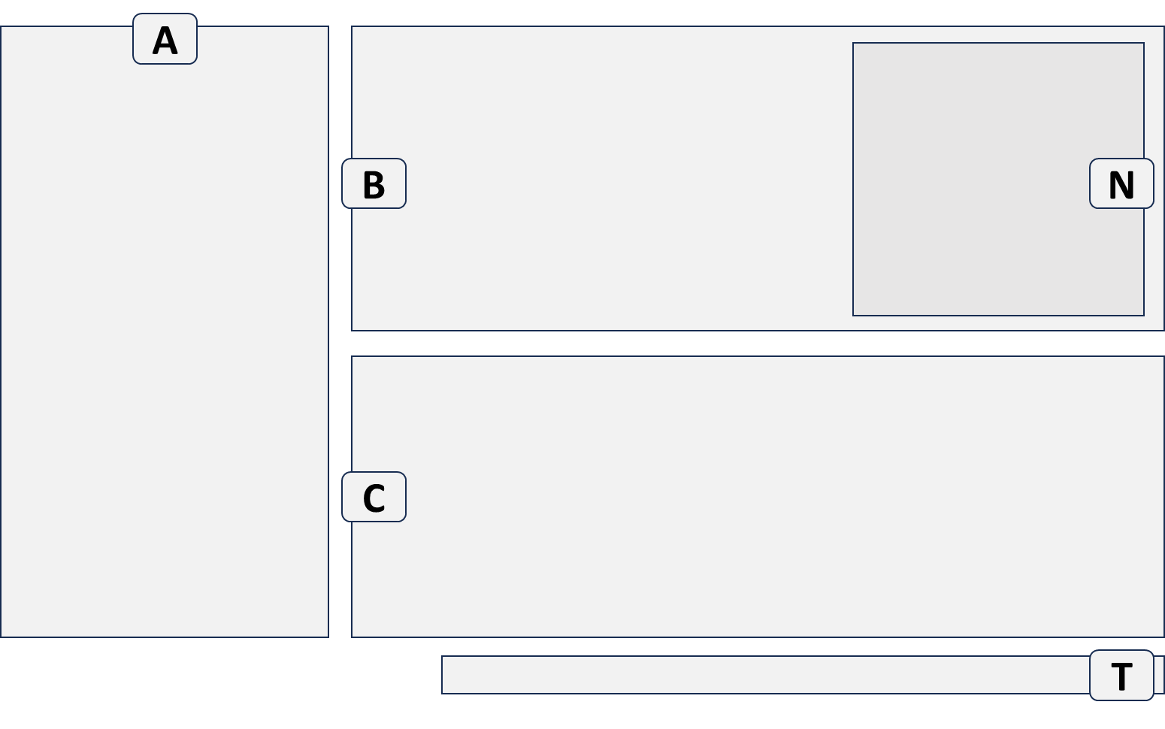

namespace eLib.Assign : int mode
mode | Tree A (content, action, menu) | Grid B (content, action, menu)  Grid C (content, action, menu)
64 | P  click: {show SP in B, newMode=192}  dblclick: {show SP in A, newMode=64} | -  -
32 | SP  click: {show SNotes in B, show Links in C, newMode=96} | -  -
50 | SP  click: {show SNotes in B, show Links in C, newMode=96} | SNotes  dblclick: {edit SNote}  Links  click: {show LNotes in B ,newMode=66}  dblclick: {Read}
16 | - | SNotes ?  dblclick: {edit SNote}  -
42 | SP  click: {show SNotes in B, show Links in C, newMode=96} | LNotes  dblclick: {edit LNote}  Links  click: {show LNotes in B ,newMode=66}  dblclick: {Read}
29 | - | SLRNotes ?  Refs ?  click: {show RNotes in B ,newMode=9}  dblclick: {Read}
5 | - | RNotes  dblclick: {edit RNote}  Refs ?  click: {show RNotes in B ,newMode=9}  dblclick: {Read}
4 | - | FNotes ?  dblclick: {edit FNote}  -
TreeA [64:P, 32:SP], GridB [16:SN, 8:LN, 4:RN], GridC [2:Link, 1:Ref]

mode | layout | bits | from
64 |  | -10 000 00 | start
32 |  | -01 000 00 | 64
50 |  | -01 100 10 | 32
16 |  | -00 100 00 | 50, 32, 64
42 |  | -01 010 10 | 50
29 |  | -00 111 01 | search
5 |  | -00 001 01 | 29
4 |  | -00 001 00 | 29

class Client
string Name  string SerialNumber  string BuildInfo  string SavedSN  string DriveSN  string InferredSN  string StoredKey  string ActivationKey  int nRequests  bool KeyIsValid  string List15Mode {RefNote, RefNoteSearch}  string List5Mode {Ref, Link, LinkNote, LinkNoteSearch, SubProjectNote,  SubProjectNoteSearch, RefNote, RefNoteSearch}  string List55Mode {LinkNote, LinkNoteSearch}  string List6Mode {SubProjectNote, SubProjectNoteSearch}  string eLibDataPath CommonDocuments  int DialogRequestParams  bit1: frmProject is requested for Project  bit2: requested for SubProject  bit3: requested for user/pass  bit4: 0:new, 1:Edit item  bit5: exit: 0:cancel, 1:ok/save  bit6: a subproject is selected from frmSelectProject/Subproject  bit7: a project is selected from frmSelectProject/Subproject  bit8: reserved bit | Methods:  GetClientName()  CreateTables()  GetClientSN()  GenerateQRCode()  SearchScholar()  OpenURL()  DeleteHtmlFiles()

class Db
string CurrentDbVersion  cnn  string CnnString  string Server2Connect  SqlConnection CnnSS  SqlCommand CmdSS  SqlDataAdapter DASS  Server  string ServerType  string ServerName  string InstanceName  int InstanceNumber  DS  DataSet DS  string BackEnd  string ServerUid  string ServerPwd  string strSQL  int BackupRegister  BackupRegister:  bit1: Backup Files (titles)  bit2: Backup Projects and subProjects  bit3: Backup Links  bit4: Backup Notes  bit5: 1:all-users (0: one-user)  bit6: backup was successful  bit7- reserved  int RestoreStatus  bit1: operation 1 done  bit2: operation 2 done | Methods:  CopyAndAttachLocalDB()  CheckDBAttached2SqlServerExpress()  ConnectTo()  ReadSettingsAndUsers()  ScanNames()  ScanPaths()  BulkCopyPaperNames()  RemoveExtension()  AddNewUser()  ChengePassword()  CreateNewRef()  Backup-Restore  Backup()  Restore()  WipeOutData  ClearPapers()  ClearProjects()  CloseDbAndExitTheApp()

class Assign
int Mode  {TreeA, GridB, GridC}  bit7 TreeA Projects  bit6 TreeA SubProjects  bit5 GridB SNotes  bit4 GridB LNotes  bit3 GridB RNotes  bit2 GridC Links  bit1 GridC Refs | bits val treeA gridB/gridC  ------------------------------------------------------------  -1- --- -- 64 A: Projects B: -  C: -  --1 --- -- 32 A: SubProjects B: -  C: -  --1 1-- 1- 50 A: SubProjects B: SNotes  C: Links  --- 1-- -- 16 a: - B: SNotes ?  C: -  --1 -1-- 1- 42 A: SubProjects B: LNotes  C: Links  --- 111 -1 29 A: - B: RNotes  C: Refs ?  --- --1 -1 5 A: - B: RNotes  C: -
Methods:  DoInitializeTheTables()  ReadAllSharingsTable()  CheckReadOnlyAccess()  DoLinkRef2SubProject()  GetProjects()  GetSubProjects()  GetSNotes()  GetSLinks()  GetRLinks()  GetLNotes()  GetRNotes()  GetImportantRefs()  GetListOfRefs()  GetSharedList()  AddNewProject()  AddNewSubProject()  AddNewNote()  EditAProject()  EditASubProject()  ReplaceALink() |  | SetRefAttributes()  DeleteAProject()  DeleteASubProject()  DeleteASubProjectNote()  DeleteAllSubProjectNotes()  DeleteALink()  DeleteALinkNote()  DeleteARef()  DeleteARefNote()  ReplaceASubProject()  ReplaceASubProjectNote()  ReportProjects()  ReportThisSubProject()  ReportAllNotesInASubproject()  AddHeader2Report()  AddFooter2Report()  ShowCollectedNotes()  DoSearchRefs()  DoSearchNotes()

class eLibFile
string cnnFilename
string Filename
string Extension
string DestinationFolder
string strFilex : for import a ref

class Security
Random Rndx
Methods:
Encode()
Decode()

class Instance
string Path
string ClientSN

class Report
int Settings
string Caption
string Header
string Footer

Registers

Interface : 1:frmAssign, 2:frmAssign2
List15Mode : RefNote, RefNoteSearch
List5Mode : Ref, Link, LinkNote, LinkNoteSearch, SubProjectNote,
SubProjectNoteSearch, RefNote, RefNoteSearch
List55Mode : LinkNote, LinkNoteSearch
List6Mode : SubProjectNote, SubProjectNoteSearch

DialogRequestParams
bit1 frmProject dialog is requested for Project
bit2 frmProject dialog is requested for SubProject
bit3 frmProject dialog is requested for user/pass
bit4 frmProject dialog is requested as 0:new, 1:Edit item
bit5 frmProject dialog is exited as 0:cancel, 1:ok/save
bit6 a subproject is selected from dialog frmSelectProject/Subproject
bit7 a project is selected from dialog frmSelectProject/Subproject
bit8 reserved

BackupRegister
bit1 Backup Files (titles)
bit2 Backup Projects and subProjects
bit3 Backup Links
bit4 Backup Notes
bit5 1:all-users (0:one-user)
bit6 backup was successful
bit7-32 reserved

RestoreStatus
bit1 operation1 accomplished
bit2 operation2 accomplished

Assign.Mode
bit7 TreeA Projects
bit6 TreeA SubProjects
bit5 GridB SNotes
bit4 GridB LNotes
bit3 GridB RNotes
bit2 GridC Links
bit1 GridC Refs

Examples
bits val treeA gridB/gridC
----------------------------------------------------------------------
-1- --- -- 64 A: Projects B: - C: -
--1 --- -- 32 A: SubProjects B: - C: -
--1 1-- 1- 50 A: SubProjects B: SNotes C: Links
--- 1-- -- 16 a: - B: SNotes ? C: -
--1 -1-- 1- 42 A: SubProjects B: LNotes C: Links
--- 111 -1 29 A: - B: RNotes C: Refs ?
--- --1 -1 5 A: - B: RNotes C: -
----------------------------------------------------------------------

ImportStatus
bit1 0:NewFileMode, 1:EditMode
bit2 0:file is selected via frmImport, 1:file is selected via frmAssign
bit3 0:no link, 1:has link
bit4 0:notReady2move/selectAnotherFile, 1:Ready2move

Refretial integrity
Table Notes includes Parent_IDs from 3 different tables {SubProjects, Papers, Links}.
Therefore refretial integrity can not be achieved using database system.
Integrity must be provided through programming in the app itself.

Rules:
1- By deleting a Link, LNotes (where Parent.ID= Link.ID and Parent.Type = L) must also be removed.
2- By deleting a Ref, RNotes (where Parent.ID= Paper.ID and Parent.Type = R) must also be removed.
3- By deleting a Ref, all its Links (where Paper_ID= Paper.ID) must also be removed.
4- By deleting some Links (in 3) their LNotes must be removed!
5- By deleting a Note (of any type {SLR}), NoteNote.records with similar Note.IDs must be removed.

Solution:
I. When deleting a Note, call the method that removes [corresponding] NoteNet records (II).
III. To delete a Link, first get a list of Note IDs corresponding to that Link, then delete those Notes one-by-one using (I).
IV. To delete a Ref, first get a list of Note IDs corresponding to that Ref, then delete those Notes one-by-one using (I).
V. Then get a list of Link IDs corresponding to that Ref, then delete those Links one-by-one using (III).

2- Exam / Eximiner

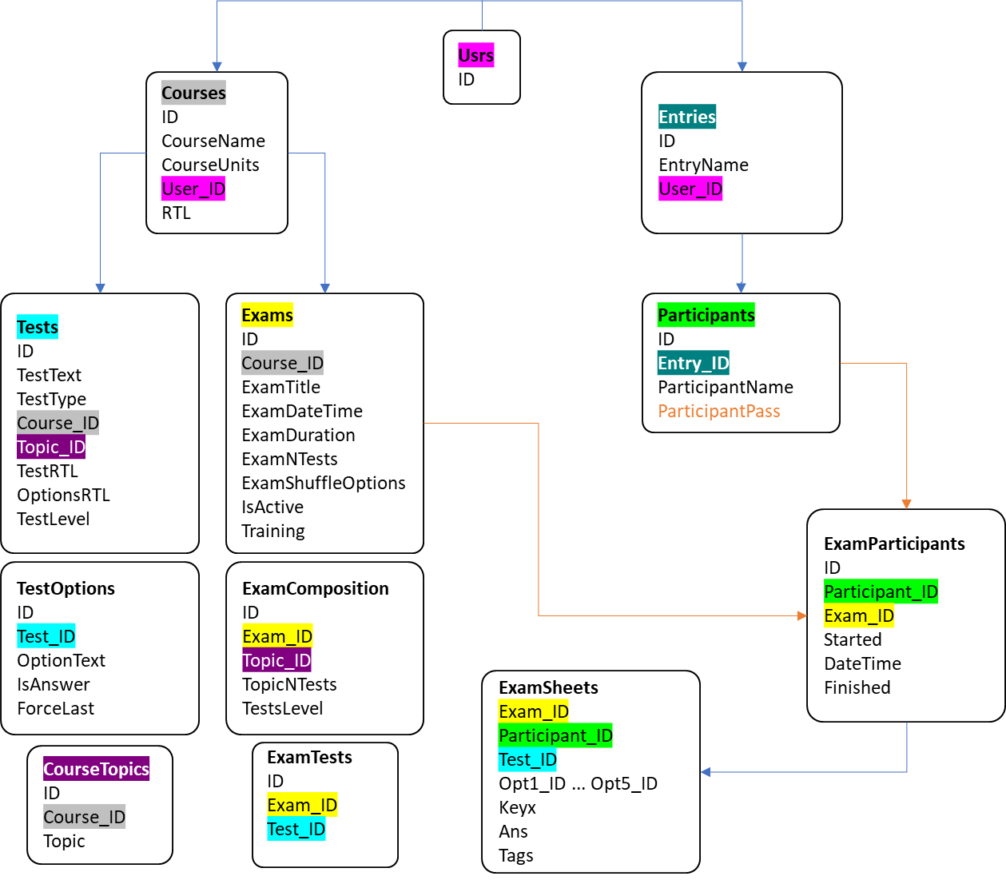
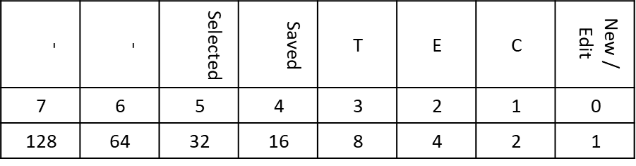

Courses
SQLServer Table | DS Table | Class
ID int  CourseName nvarchar(30)  CourseUnits int  user_ID int  RTL bit | tblCourses  0 ID  1 CourseName  2 CourseUnits  3 user_ID | Course.Id  Course.Index  Course.Name  Course.Units  Course.RTL

CourseTopics
ID int  Course_ID int  Topic nvarchar(30) | tblCourseTopics  ID  0 Course_ID  1 Topic | Topic.Id  Topic.Index  Topic.Text  Topic.nTests

Entries
0 ID int  1 EntryName nvarchar(50)  2 User_ID int | tblEntries  0 ID  1 EntryName  2 User_ID

ExamComposition
ID int  Exam_ID int  Topic_ID int  TopicNTests int  TestsLevel int | tblExamComposition  0 ExamComposition.ID  1 Exam_ID  2 Topic_ID  3 Topic  4 TopicNTests  5 TestsLevel | ExamComposition.Id  ExamComposition.ExamId  ExamComposition.TopicId  ExamComposition.nTests  ExamComposition.TestsLevel

ExamParticipants
0 ID int  1 Participant_ID int  2 Exam_ID int  3 Started bit  4 DateTime nchar(18)  5 Finished bit  6 Point float | tblExamParticipants  0 ExamParticipants.ID  1 Participant_ID  2 Exam_ID  3 ParticipantName  4 ParticipantPass  5 Started  6 DateTime  7 Finished  8 ExamPoint | Participant.Id  Participant.Name  Participant.Pass  Participant.Started  Participant.DateTime  Participant.Finished

Exams
ID int  Course_ID int  ExamTitle nvarchar(100)  ExamDateTime nchar(18)  ExamDuration int  ExamNTests int  ExamShuffleOptions bit  IsActive bit  Training bit | tblExams  0 ID  1 Course_ID  2 ExamTitle  3 ExamDateTime  4 ExamDuration  5 ExamNTests  6 ExamShuffleOptions  7 IsActive  8 Training | Exam.Id  Exam.Index  Exam.Title  Exam.DateTime  Exam.Duration  Exam.nTests  Exam.ShuffleOptions  Exam.IsActive  Exam.Training

ExamSheets
0 Exam_ID int  1 participant_ID int  2 Test_ID int  3 Opt1_ID int  4 Opt2_ID int  5 Opt3_ID int  6 Opt4_ID int  7 Opt5_ID int  8 Keyx int  9 Ans int  10 Tags int | tblExamSheets  0 Exam_ID  1 Participant_ID  2 Test_ID  3 Opt1_ID  4 Opt2_ID  5 Opt3_ID  6 Opt4_ID  7 Opt5_ID  8 Keyx  9 Ans  10 Tags

ExamTests
ID int  Exam_ID int  Test_ID int | tblExamTests  0 Tests.ID  1 ExamTests.ID  2 TestText  3 TestType  4 Course_ID  5 Topic_ID  6 TestRTL  7 OptionsRTL  8 TestLevel

Participants
0 ID int  1 Entry_ID int  2 ParticipantName nvarchar(40)  3 ParticipantPass char(8) | tblEntryParticipants  0 ID  1 Entry_ID  2 ParticipantName  3 ParticipantPass | Participant.Id  Participant.Name  Participant.Pass  Participant.Started  Participant.DateTime  Participant.Finished

Settings
0 ID int  1 sttHeader nvarchar(50)  2 sttKey nvarchar(50)  3 sttValue nvarchar(255)  4 sttNote nvarchar(255) | tblSettings  0 ID  1 sttHeader  2 sttKey  3 sttValue  4 sttNote

TestOptions
ID int  Test_ID int  OptionText nvarchar(420)  IsAnswer bit  ForceLast bit | tblTestOptions  0 ID  1 Test_ID  2 OptionText  3 ISAnswer  4 ForceLast  (rows: opts1-5)

Tests
ID int  TestText nvarchar(580)  TestType int  Course_ID int  Topic_ID int  TestRTL bit  OptionsRTL bit  TestLevel int | tblTests  0 ID  1 TestText  2 TestType  3 Course_ID  4 Topic_ID  5 TestRTL  6 OptionsRTL  7 TestLevel | Test.Id  Test.Index  Test.Text  Test.Type  Test.TopicId  Test.TestRTL  Test.OptionsRTL  Test.Level  Test.ForceLast

class Testbank
regTestBank
bit1 0:AddNew, 1:Edit
bit2 1:Course
bit3 1:Exam
bit4 1:Test
bit5 0:Canceled, 1:Saved
bit6 0:Canceled, 1:Selected
bit7 reserved
bit8 reserved
CourseId
CourseIndex
CourseTopicId
CourseTopicIndex
ExamId
ExamIndex
TestId
TestIndex
PasteOnDblClick = false
CourseRTL = false //is used in frmCET
EntryId

Methods
//COURSES
GetCourses (int userid)
GetCourseTopics (int crsid)
SaveCourse ()
DeleteCourseById (int courseid)
//EXAMS
GetExams (int crsid)
GetExamById (int examid)
GetExamComposition (int examid)
AddExam (int intcourseid)
AddExamComposition (int examid, int topicid, int ntests)
UpdateExam (int examid)
UpdateExamComposition (int compId, int topicId, int nTests)
DeleteExamById (int examid)
//TESTS-OPTIONS
GetTests (int parentId, string parent)
GetTestOptions (int testid)
GetTestById (int testid)
AddNewTest (int parentid, string parent)
AddTestOption (int testid, string optionText, bool IsAns)
ImportTest (int courseId)
UpdateTest (int id, string mode)
UpdateTestOption (int optId, string optText, bool optIsAns, bool optForce)
DeleteTestOptionById (int testOptionId)
//ENTRIES
GetEntries (int userId)
AddNewEntry (int userId, string entryName)
UpdateEntry (int entryId, string entryName)
//PARTICIPANTS
GetParticipantsOfEntry (int entryId)
GetParticipantsOfExam (int examId)
AddNewParticipant2Entry (int entryId, string participantName, string participantPass)
UpdateParticipant (int participantId, string participantName, string participantPass)
AddAllParticipants2Exam (int entryId, int examId)
AddOneParticipant2Exam (int participantId, int examId)
RemoveAllParticipantsFromExam (int examId)
RemoveOnePrticipantFromExam (int examId, int participantId)

class Testbank: methods
Method | parameters | notes
//COURSES and TOPICS
GetCourses () | int userid
GetCourseTopics () | int crsid
GetIdOfThisTopic () | int courseId  str topicText
SaveCourse ()
AddNewCourseTopic () | int courseId  str topicText
DeleteCourseById () | int courseid
//EXAMS
GetExams () | int crsid
GetExamById () | int examid
GetExamComposition () | int examid
AddExam () | int intcourseid
AddExamComposition () | int examid  int topicid  int ntests
UpdateExam () | int examid
UpdateExamComposition () | int compId  int topicId  int nTests  int testsLevel
DeleteExamById () | int examid
DeleteExamComposition () | int compId
AddRandomTestsToExam () | int examId  int topicId  int nTests  int testlevel
//TESTS and OPTIONS
GetTests () | int parentId  str parent  int topicId
GetTestById () | int testid
GetTestOptions () | int testid
GetTestOptionById () | int optionid
AddNewCourseTest () | int courseId  int testType
AddNewExamTest () | int examId  int testId
AddTestOption () | int testid  str optionText  bool IsAns  bool forceLast
ImportTest () | int courseId  str testText  int testType  int topicId  bool testRTL  bool optionsRTL  int testLevel
UpdateTest () | int id  string mode
UpdateTestOption () | int optId  str optText  bool optIsAns  bool optForce
DeleteTestOptionById () | int testOptionId
//ENTRIES
GetEntries () | int userId
AddNewEntry () | int userId  str entryName
UpdateEntry () | int entryId  str entryName
//PARTICIPANTS and EXAMSHEETS
GetEntryParticipants () | int entryId
GetParticipantById () | int participantId
GetExamParticipants () | int examId
GetAllParticipantExams () | int participantId
GetParticipantExamSheet () | int examId  int participantId
GetTestOptionsText () | int examTestId
GetExamTestById () | int examtestId
AddNewParticipant2Entry () | int entryId  str participantName  str participantPass
AddAllParticipants2Exam () | int entryId  int examId
AddOneParticipant2Exam () | int participantId  int examId
UpdateParticipant () | int participantId  str participantName  str participantPass
RemoveAllParticipantsFromExam () | int examId
RemoveOneParticipantFromExam () | int examId  int participantId
//Printout-HTML
PrintoutExamParticipantsUserPass ()
PrintoutRawExamSheets () | int examId  int participantId
PrintoutExamMarks () | int examId
PrintoutExamRecords () | int examId  int participantId

Registers
Test_Level
bit1 (1) : Elementary
bit2 (2) : Pre-intermediate
bit3 (4) : Intermediate
bit4 (8) : Upper-intermediate
bit5 (16): Upper Level

3- ExaminerW

Public Classes
Exmw | notes
public static string cnnString =
@"Data Source=31.25.91.22;
Initial Catalog=msht_eLib;
User ID=msht_eLib1AppUser;
Password=eLiB1_dRmShT2733;
TrustServerCertificate=True;"
ParticipantExam | notes
public int ParticipantId
public string ParticipantName
public string ParticipantPass
public int CourseId
public string CourseName
public int ExamId
public int ExamIndex
public string ExamTitle
public string ExamDateTime
public int ExamDuration
public int ExamNTests
public bool ExamIsActive
public bool ExamIsTraining
public bool ExamIsStarted
public string ExamDateTimeStarted
public bool ExamIsFinished
public float ExamPoint (new)
ExamSheetTest | notes
public int examId
public int participantId
public int TestIndex
public int TestId
public string TestText
public int Type
public int TopicId
public string TopicName
public bool TestRTL
public bool OptionsRTL
public int Level
public int Opt1_ID
public int Opt2_ID
public int Opt3_ID
public int Opt4_ID
public int Opt5_ID
public string Opt1_Text
public string Opt2_Text
public string Opt3_Text
public string Opt4_Text
public string Opt5_Text
public int Key
public int Ans
public int Tags
TestOption | notes
public int Id
public int TestId
public string Text
public Boolean IsAnswer
public Boolean ForceLast

HttpContext
HttpContext.Session | notes
SetInt32 ("participantId", 0);
SetString ("EntryName", "");
SetString ("participantName", "");
SetInt32 ("participantLoginStatus", 0);
SetInt32 ("selectedExamId", 0);
SetInt32 ("selectedTestId", 0);
SetInt32 ("selectedTestIndex", 0);
SetInt32 ("selectedTestOptionId", 0);

Pages
page Login
public ParticipantExam participantExam = new ParticipantExam ();
public string? txtUser
public string? txtPass
public IActionResult OnPostBtnLogin ()
private void resetParticipantExam ()
public int CheckUserPass (string usr, string pwd)
page Index
public static ParticipantExam participantExam = new ParticipantExam ();
public List<ParticipantExam> lstParticipantExams = new List<ParticipantExam> ();
public IActionResult OnPostBtnStartExam (int Id)
public long GetExamList (int participantId)
page Exam
public int participantId = 0;
public int examId = 0;
public ParticipantExam participantExam = new ParticipantExam ();
public List<ExamSheetTest> lstExamSheetTests = new List<ExamSheetTest> ();
public IActionResult OnPostBtnShowTest (int Id)
public void GetExamInfoById (int examId)
public void GetExamSheetTestsInfo (int participantId, int examId)
page Test
public ExamSheetTest test = new Test ();
public List<TestOption> lstExamSheetTestOptions = new List<TestOption> ();
public IActionResult OnPostBtnChooseOptionAsAnswer (int Id)
public void GetExamSheetTest (int examSheetTestId)
public void GetExamSheetTestOptions (int examSheetTestId)
public static void SaveExamSheet ()
public static void SetExamStartTag ()
public static void SetExamFinishTag ()
public static void GetTestOptionById (int optionid)

page -

page -

4- Augustus

ArrowData
SQLServer Table | DS Table | Class
0 Species nvarchar 255  1 NRPS nvarchar 255  2 Gene nvarchar 255  3 size float  4 Dir nvarchar 255  4 Description nvarchar 255  5 Dye nvarchar 255 | tblArrows  0 Species  1 Cluster  2 Gene  3 Spacer  4 Size  5 Dir  6 Description  7 Dye  8 Sel

Clusters
0 ID int  1 ClusterName varchar 250  2 Species_ID int | tblClusters  0 ID  1 ClusterName  2 Species_ID

NoteNet
0 ID int  1 NoteA_ID int  2 NoteB_ID int | tblNoteNet  0 ID  1 NoteA_ID  2 NoteB_ID

Sequences
0 ID int  1 ParentType int  2 Parent_ID int  3 SequenceType int  4 SequenceText varchar(MAX) | x | Sequence.Id  Sequence.ParentType  Sequence.ParentId  Sequence.SequenceType  Sequence.SequenceText

species
ID int  SciName varchar(60)  Taxonomy varchar(200)  Project_ID int | tblSpecies  0 ID  1 SciName  2 Taxonomy  3 Project_ID

Transcripts
0 ID int  1 TranscriptName varchar(200)  2 Cluster_ID int  3 SpacerLength int  4 TranscriptFrom int  5 TranscriptTo int  6 GeneSize int  7 Direction char(1)  8 Description varchar(250)  9 Sel bit  10 Info varchar(MAX) | tblTranscripts  0 ID  1 TranscriptName  2 Cluster_ID  3 SpacerLength  4 TranscriptFrom  5 TranscriptTo  6 GeneSize  7 Direction  8 Description  9 Sel  10 Info | Transcript.Id  Transcript.Name  Transcript.ClusterId  Transcript.SpacerLength  Transcript.TranscriptFrom  Transcript.TranscriptTo  Transcript.GeneSize  Transcript.PereviousGeneEnd  Transcript.Direction  Transcript.Description  Transcript.Sel  Transcript.Info

-
tblPalette
0 ID
1 R
2 G
3 B

5- Encode
prefix |  |  | data |  |  |  |  | data |  |  |  |  | data |  |  |  |  |  | suffix
t | s | nnn | t | s | nnn | t | hh | t | s | nnn | t | hh | t | s | nnn | t | hh | x |  | nnn

Prefix (tsnnn)
t | s | nulls | Prefix
[1-9] | [32-126] | [32-126]
t=rnd([]) | n=rnd([]) | c=coef(t,n) | tsnnn
 | s=chr (n) | nnn=c.[chr(rnd([]))]
t | s | nulls | Prefix
9 -> 4 | 102 | coef(4,102)=4 | 9fV;o]
 | chr(102)="f" | 86,59,111,93
 |  | chr(86,59,111,93)="V;o]"

Encoding chars (tsnnnthh)
example: SN= 18D
t | s | nulls | t | hh | Result
[1-9] | [32-126] | [32-126] | [1-9]
t=rnd([]) | n=rnd([]) | c=coef(n,t) | t=rnd([]) | d=SN(i) | tsnnnthh
 | s=chr(n) | nnn=c.chr(rnd([])) | odd/even? | a=asc("d")
 |  |  |  | E=encr(a,t)
 |  |  |  | hh=hex(E)
 |  |  |  | (odd(t)=T)? hh=inv(h)
t | s | nulls | t | hh | Result
8 -> 3 | 43 | coef(3,43)=2 | 5 | d="1" | 8+F45C4
 | chr(43)="+" | 70,52 | odd | asc("1")=49
 |  |  |  | encr(49,5)=76
 |  | chr(70,52)="F4" |  | hex(76)=4C -> inv=C4
t | s | nulls | t | hh | Result
6 -> 1 | 59 | coef(1,59)=1 | 4 | d="8" | 6;=44A
 | chr(59)=";" | 61 | even | asc("8")=56
 |  |  |  | encr(4,56)=74
 |  | chr(61)="=" |  | hex(74)=4A
t | s | nulls | t | hh | Result
2 | 75 | coef(2,75)=1 | 7 | d="D" | 2K^762
 | chr(75)="K" | 94 | odd | asc("D")=68
 |  |  |  | encr(2,68)=38
 |  | chr(94)="^" |  | hex(38)=26 -> inv=62

Suffix (xnnn)

x | nnn | suffix
[1-9] | [32-126]
x=rnd([]) | nnn=n.[chr(rnd([]))] | xnnn
n | nnn | suffix
8 -> 3 | 44,83,112 chr(44,83,112)=",Sp" | 8,Sp

Decoding

Romeve prefix | Consider t,s | c=Select coef from Table Where T(t)=asc(s)
 |  | Number of prefix chars to remove: c+2
Extract data | Consider t,s | c=Select coef from Encr Where T(t)=asc(s)
 |  | remove(c+2) chars
 | Consider t,hh | if (odd(t)=true): E=decimal(invert(hh)) ELSE E=Decimal(hh)
 |  | D=select ascii code from Table Where T(t)=E
 |  | d=chr(D)
if (enough character remained): Repeat

TABLE Ascii codes, coefficients
Ascii codes, encriptions, and coefficients

ascii | chr | T1 | T2 | T3 | T4 | T5 | C |  | i | T1(i) | C | T2(i) | C | T3(i) | C | T4(i) | C | T5(i) | C
32 | spc | 85 | 32 | 45 | 64 | 54 | 3 |  | 32 | 51 | 1 | 32 | 3 | 123 | 2 | 58 | 1 | 54 | 4
33 | ! | 104 | 53 | 57 | 90 | 67 | 1 |  | 33 | 112 | 3 | 80 | 4 | 93 | 2 | 124 | 3 | 47 | 2
34 | " | 93 | 89 | 84 | 91 | 86 | 2 |  | 34 | 47 | 2 | 119 | 1 | 60 | 3 | 75 | 1 | 126 | 2
35 | # | 123 | 90 | 85 | 116 | 77 | 3 |  | 35 | 76 | 3 | 68 | 3 | 80 | 4 | 60 | 3 | 56 | 2
36 | $ | 77 | 91 | 56 | 120 | 123 | 4 |  | 36 | 72 | 1 | 121 | 4 | 119 | 1 | 79 | 4 | 76 | 3
37 | % | 59 | 116 | 77 | 70 | 42 | 1 |  | 37 | 121 | 4 | 52 | 2 | 97 | 4 | 107 | 1 | 45 | 4
38 | & | 49 | 120 | 78 | 66 | 85 | 2 |  | 38 | 99 | 2 | 125 | 1 | 113 | 4 | 81 | 4 | 49 | 3
39 | ' | 65 | 121 | 102 | 71 | 119 | 3 |  | 39 | 87 | 2 | 61 | 1 | 56 | 2 | 101 | 4 | 71 | 4
40 | ( | 66 | 54 | 103 | 110 | 104 | 4 |  | 40 | 66 | 3 | 65 | 2 | 76 | 3 | 102 | 1 | 87 | 2
41 | ) | 101 | 87 | 104 | 122 | 93 | 1 |  | 41 | 54 | 4 | 63 | 3 | 77 | 4 | 82 | 1 | 121 | 4
42 | * | 46 | 88 | 47 | 123 | 114 | 2 |  | 42 | 123 | 2 | 60 | 3 | 58 | 1 | 111 | 3 | 37 | 1
43 | + | 110 | 67 | 93 | 86 | 65 | 1 |  | 43 | 59 | 2 | 74 | 4 | 117 | 2 | 93 | 2 | 90 | 1
44 | , | 109 | 103 | 60 | 50 | 80 | 2 |  | 44 | 103 | 2 | 75 | 1 | 124 | 3 | 86 | 1 | 92 | 3
45 | - | 94 | 101 | 121 | 125 | 37 | 4 |  | 45 | 52 | 2 | 67 | 2 | 32 | 3 | 59 | 2 | 55 | 1
46 | . | 62 | 46 | 65 | 96 | 52 | 1 |  | 46 | 42 | 2 | 46 | 1 | 82 | 1 | 92 | 3 | 89 | 4
47 | / | 34 | 73 | 99 | 63 | 33 | 2 |  | 47 | 79 | 4 | 66 | 3 | 42 | 2 | 115 | 4 | 93 | 2
48 | 0 | 111 | 72 | 100 | 107 | 125 | 3 |  | 48 | 90 | 1 | 106 | 4 | 111 | 3 | 116 | 1 | 73 | 3
49 | 1 | 79 | 63 | 61 | 88 | 38 | 3 |  | 49 | 38 | 2 | 100 | 3 | 102 | 1 | 99 | 2 | 114 | 3
50 | 2 | 98 | 124 | 82 | 117 | 74 | 4 |  | 50 | 110 | 4 | 55 | 1 | 87 | 2 | 44 | 2 | 61 | 1
51 | 3 | 32 | 75 | 58 | 55 | 105 | 1 |  | 51 | 91 | 2 | 76 | 3 | 88 | 3 | 112 | 3 | 62 | 2
52 | 4 | 45 | 37 | 83 | 93 | 97 | 2 |  | 52 | 122 | 1 | 89 | 4 | 110 | 4 | 108 | 2 | 46 | 1
53 | 5 | 73 | 102 | 59 | 126 | 98 | 3 |  | 53 | 55 | 1 | 33 | 1 | 72 | 1 | 109 | 3 | 122 | 1
54 | 6 | 41 | 114 | 55 | 92 | 32 | 4 |  | 54 | 118 | 1 | 40 | 4 | 98 | 1 | 72 | 1 | 32 | 3
55 | 7 | 53 | 50 | 113 | 56 | 45 | 1 |  | 55 | 67 | 2 | 102 | 1 | 54 | 4 | 51 | 1 | 99 | 2
56 | 8 | 89 | 115 | 39 | 94 | 35 | 2 |  | 56 | 70 | 3 | 103 | 2 | 36 | 4 | 55 | 1 | 109 | 3
57 | 9 | 126 | 106 | 123 | 98 | 91 | 4 |  | 57 | 105 | 4 | 78 | 1 | 33 | 1 | 61 | 1 | 64 | 4
58 | : | 61 | 122 | 42 | 32 | 116 | 1 |  | 58 | 84 | 3 | 98 | 1 | 51 | 1 | 97 | 4 | 96 | 3
59 | ; | 43 | 123 | 62 | 45 | 120 | 2 |  | 59 | 37 | 1 | 99 | 2 | 53 | 3 | 98 | 1 | 100 | 3
60 | < | 124 | 42 | 34 | 35 | 70 | 3 |  | 60 | 78 | 1 | 94 | 1 | 44 | 2 | 80 | 4 | 75 | 1
61 | = | 96 | 39 | 111 | 57 | 50 | 1 |  | 61 | 58 | 1 | 95 | 2 | 49 | 3 | 118 | 1 | 79 | 4
62 | > | 64 | 109 | 72 | 84 | 51 | 2 |  | 62 | 46 | 1 | 79 | 4 | 59 | 2 | 74 | 4 | 125 | 1
63 | ? | 99 | 41 | 73 | 85 | 112 | 3 |  | 63 | 124 | 3 | 49 | 3 | 75 | 1 | 47 | 2 | 104 | 3
64 | @ | 90 | 64 | 74 | 119 | 57 | 4 |  | 64 | 62 | 2 | 64 | 4 | 78 | 1 | 32 | 3 | 82 | 1
65 | A | 95 | 40 | 89 | 87 | 107 | 2 |  | 65 | 39 | 3 | 92 | 3 | 46 | 1 | 88 | 3 | 43 | 1
66 | B | 40 | 47 | 118 | 76 | 111 | 3 |  | 66 | 40 | 4 | 71 | 4 | 105 | 4 | 38 | 2 | 83 | 2
67 | C | 55 | 45 | 107 | 111 | 109 | 2 |  | 67 | 111 | 3 | 43 | 1 | 125 | 1 | 71 | 4 | 33 | 1
68 | D | 103 | 35 | 76 | 72 | 73 | 3 |  | 68 | 88 | 3 | 85 | 4 | 106 | 4 | 84 | 3 | 102 | 1
69 | E | 83 | 74 | 110 | 105 | 99 | 2 |  | 69 | 102 | 1 | 86 | 1 | 107 | 1 | 85 | 4 | 103 | 2
70 | F | 56 | 105 | 101 | 97 | 90 | 3 |  | 70 | 97 | 4 | 87 | 2 | 108 | 2 | 37 | 1 | 60 | 3
71 | G | 80 | 66 | 92 | 67 | 39 | 4 |  | 71 | 107 | 1 | 88 | 3 | 109 | 3 | 39 | 3 | 84 | 3
72 | H | 36 | 108 | 53 | 54 | 92 | 1 |  | 72 | 81 | 4 | 48 | 3 | 62 | 2 | 68 | 3 | 106 | 4
73 | I | 76 | 81 | 125 | 82 | 48 | 3 |  | 73 | 53 | 3 | 47 | 2 | 63 | 3 | 120 | 2 | 68 | 3
74 | J | 100 | 43 | 96 | 62 | 106 | 4 |  | 74 | 100 | 3 | 69 | 2 | 64 | 4 | 123 | 2 | 50 | 4
75 | K | 117 | 44 | 63 | 34 | 60 | 1 |  | 75 | 116 | 1 | 51 | 1 | 96 | 3 | 106 | 4 | 124 | 3
76 | L | 35 | 51 | 40 | 108 | 36 | 3 |  | 76 | 73 | 3 | 114 | 3 | 68 | 3 | 66 | 3 | 117 | 2
77 | M | 106 | 112 | 41 | 114 | 95 | 4 |  | 77 | 36 | 4 | 91 | 2 | 37 | 1 | 94 | 1 | 35 | 3
78 | N | 60 | 57 | 64 | 115 | 79 | 1 |  | 78 | 126 | 2 | 104 | 3 | 38 | 2 | 95 | 2 | 97 | 4
79 | O | 47 | 62 | 90 | 36 | 61 | 4 |  | 79 | 49 | 3 | 118 | 1 | 114 | 3 | 91 | 2 | 78 | 1
80 | P | 114 | 33 | 35 | 60 | 87 | 4 |  | 80 | 71 | 4 | 93 | 2 | 115 | 4 | 104 | 3 | 44 | 2
81 | Q | 72 | 111 | 122 | 38 | 96 | 4 |  | 81 | 82 | 1 | 73 | 3 | 116 | 1 | 121 | 4 | 107 | 1
82 | R | 81 | 110 | 46 | 41 | 64 | 1 |  | 82 | 117 | 2 | 96 | 3 | 50 | 4 | 73 | 3 | 91 | 2
83 | S | 122 | 86 | 94 | 118 | 66 | 2 |  | 83 | 69 | 2 | 97 | 4 | 52 | 2 | 122 | 1 | 108 | 2
84 | T | 58 | 118 | 108 | 68 | 71 | 3 |  | 84 | 125 | 1 | 105 | 4 | 34 | 2 | 62 | 2 | 95 | 2
85 | U | 97 | 68 | 114 | 69 | 110 | 4 |  | 85 | 32 | 3 | 112 | 3 | 35 | 3 | 63 | 3 | 38 | 2
86 | V | 113 | 69 | 115 | 44 | 122 | 1 |  | 86 | 120 | 2 | 83 | 2 | 126 | 2 | 43 | 1 | 34 | 2
87 | W | 39 | 70 | 50 | 121 | 40 | 2 |  | 87 | 93 | 2 | 41 | 1 | 99 | 2 | 65 | 2 | 80 | 4
88 | X | 68 | 71 | 51 | 65 | 101 | 3 |  | 88 | 115 | 4 | 42 | 2 | 100 | 3 | 49 | 3 | 119 | 1
89 | Y | 119 | 52 | 112 | 99 | 46 | 4 |  | 89 | 56 | 2 | 34 | 2 | 65 | 2 | 110 | 4 | 123 | 2
90 | Z | 48 | 94 | 91 | 95 | 43 | 1 |  | 90 | 64 | 4 | 35 | 3 | 79 | 4 | 33 | 1 | 70 | 3
91 | [ | 51 | 77 | 116 | 79 | 82 | 2 |  | 91 | 94 | 1 | 36 | 4 | 90 | 1 | 34 | 2 | 57 | 4
92 | / | 121 | 65 | 126 | 46 | 44 | 3 |  | 92 | 106 | 4 | 107 | 1 | 71 | 4 | 54 | 4 | 72 | 1
93 | ] | 87 | 80 | 33 | 43 | 47 | 2 |  | 93 | 34 | 2 | 110 | 4 | 43 | 1 | 52 | 2 | 41 | 1
94 | ^ | 91 | 60 | 105 | 77 | 118 | 1 |  | 94 | 45 | 4 | 90 | 1 | 83 | 2 | 56 | 2 | 105 | 4
95 | _ | 116 | 61 | 124 | 78 | 84 | 2 |  | 95 | 65 | 2 | 122 | 1 | 120 | 2 | 90 | 1 | 77 | 4
96 | ` | 120 | 82 | 75 | 104 | 58 | 3 |  | 96 | 61 | 1 | 123 | 2 | 74 | 4 | 46 | 1 | 81 | 4
97 | a | 70 | 83 | 37 | 58 | 78 | 4 |  | 97 | 85 | 4 | 115 | 4 | 121 | 4 | 70 | 3 | 52 | 2
98 | b | 107 | 58 | 54 | 59 | 113 | 1 |  | 98 | 50 | 4 | 116 | 1 | 122 | 1 | 57 | 4 | 53 | 3
99 | c | 38 | 59 | 87 | 49 | 55 | 2 |  | 99 | 63 | 3 | 117 | 2 | 47 | 2 | 89 | 4 | 69 | 2
100 | d | 74 | 49 | 88 | 113 | 59 | 3 |  | 100 | 74 | 4 | 124 | 3 | 48 | 3 | 126 | 2 | 116 | 1
101 | e | 105 | 113 | 117 | 39 | 121 | 4 |  | 101 | 41 | 1 | 45 | 4 | 70 | 3 | 103 | 2 | 88 | 3
102 | f | 69 | 55 | 49 | 40 | 68 | 1 |  | 102 | 108 | 2 | 53 | 3 | 39 | 3 | 105 | 4 | 112 | 3
103 | g | 44 | 56 | 119 | 101 | 69 | 2 |  | 103 | 68 | 3 | 44 | 2 | 40 | 4 | 125 | 1 | 115 | 4
104 | h | 112 | 78 | 120 | 80 | 63 | 3 |  | 104 | 33 | 1 | 126 | 2 | 41 | 1 | 96 | 3 | 40 | 4
105 | i | 57 | 84 | 66 | 102 | 94 | 4 |  | 105 | 101 | 4 | 70 | 3 | 94 | 1 | 69 | 2 | 51 | 1
106 | j | 92 | 48 | 68 | 75 | 72 | 4 |  | 106 | 77 | 4 | 57 | 4 | 118 | 1 | 117 | 2 | 74 | 4
107 | k | 71 | 92 | 69 | 37 | 81 | 1 |  | 107 | 98 | 1 | 120 | 2 | 67 | 2 | 48 | 3 | 65 | 2
108 | l | 102 | 126 | 70 | 52 | 83 | 2 |  | 108 | 119 | 1 | 72 | 1 | 84 | 3 | 76 | 3 | 111 | 3
109 | m | 115 | 125 | 71 | 53 | 56 | 3 |  | 109 | 44 | 2 | 62 | 2 | 112 | 3 | 119 | 1 | 67 | 2
110 | n | 50 | 93 | 52 | 89 | 126 | 4 |  | 110 | 43 | 1 | 82 | 1 | 69 | 2 | 40 | 4 | 85 | 4
111 | o | 67 | 117 | 48 | 42 | 108 | 3 |  | 111 | 48 | 3 | 81 | 4 | 61 | 1 | 67 | 2 | 66 | 3
112 | p | 33 | 85 | 109 | 51 | 102 | 3 |  | 112 | 104 | 3 | 77 | 4 | 89 | 4 | 113 | 4 | 63 | 3
113 | q | 125 | 119 | 38 | 112 | 115 | 4 |  | 113 | 86 | 1 | 101 | 4 | 55 | 1 | 100 | 3 | 98 | 1
114 | r | 118 | 76 | 79 | 124 | 49 | 3 |  | 114 | 80 | 4 | 54 | 4 | 85 | 4 | 77 | 4 | 42 | 2
115 | s | 88 | 97 | 80 | 47 | 103 | 4 |  | 115 | 109 | 3 | 56 | 2 | 86 | 1 | 78 | 1 | 113 | 4
116 | t | 75 | 98 | 81 | 48 | 100 | 1 |  | 116 | 95 | 2 | 37 | 1 | 91 | 2 | 35 | 3 | 58 | 1
117 | u | 82 | 99 | 43 | 106 | 76 | 2 |  | 117 | 75 | 1 | 111 | 3 | 101 | 4 | 50 | 4 | 120 | 2
118 | v | 54 | 79 | 106 | 61 | 124 | 1 |  | 118 | 114 | 3 | 84 | 3 | 66 | 3 | 83 | 2 | 94 | 1
119 | w | 108 | 34 | 36 | 109 | 88 | 1 |  | 119 | 89 | 4 | 113 | 4 | 103 | 2 | 64 | 4 | 39 | 3
120 | x | 86 | 107 | 95 | 73 | 117 | 2 |  | 120 | 96 | 3 | 38 | 2 | 104 | 3 | 36 | 4 | 59 | 2
121 | y | 37 | 36 | 97 | 81 | 41 | 4 |  | 121 | 92 | 3 | 39 | 3 | 45 | 4 | 87 | 2 | 101 | 4
122 | z | 52 | 95 | 98 | 83 | 53 | 1 |  | 122 | 83 | 2 | 58 | 1 | 81 | 4 | 41 | 1 | 86 | 1
123 | { | 42 | 96 | 32 | 74 | 89 | 2 |  | 123 | 35 | 3 | 59 | 2 | 57 | 4 | 42 | 2 | 36 | 4
124 | | | 63 | 100 | 44 | 33 | 75 | 3 |  | 124 | 60 | 3 | 50 | 4 | 95 | 2 | 114 | 3 | 118 | 1
125 | } | 84 | 38 | 67 | 103 | 62 | 1 |  | 125 | 113 | 4 | 109 | 3 | 73 | 3 | 45 | 4 | 48 | 3
126 | ~ | 78 | 104 | 86 | 100 | 34 | 2 |  | 126 | 57 | 4 | 108 | 2 | 92 | 3 | 53 | 3 | 110 | 4

